Immutable Ledger

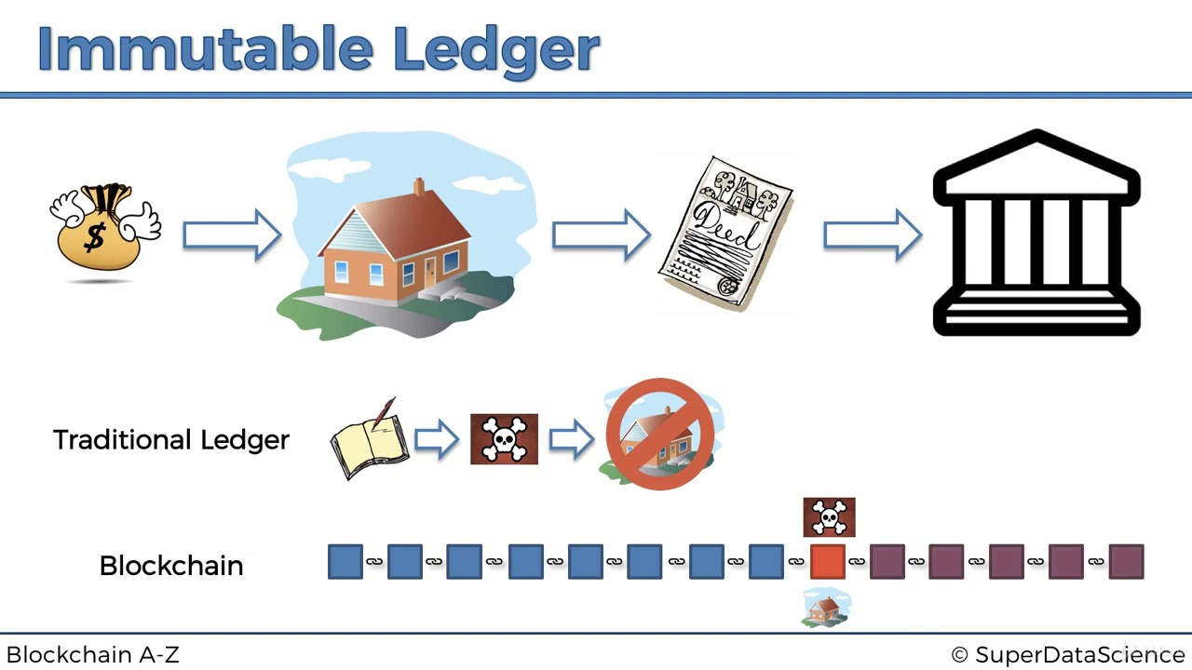

Source:

The blockchain economy: a beginner’s guide to institutional cryptoeconomics